Day 25 - 09th Aug 2025

Task 1:

Actual complete code is in the code for reference folder →OOAD → Bridge Method

Part of the code -main.java

public class Square extends Shape{

private int s;

// ExcalidrawAPI excalidrawAPI;

Square(int s,ExcalidrawAPI excalidrawAPIobj ) {

super(excalidrawAPIobj);

// super(ExcalidrawAPI excalidrawAPI); // need to check

this.s = s;

}

@Override

void draw() {

excalidrawAPI.drawSquare(s);

}

}

Task 02

Composite

Actual complete code is in the code for reference folder →OOAD →

Task 03:

Facade

Actual complete code is in the code for reference folder →OOAD →

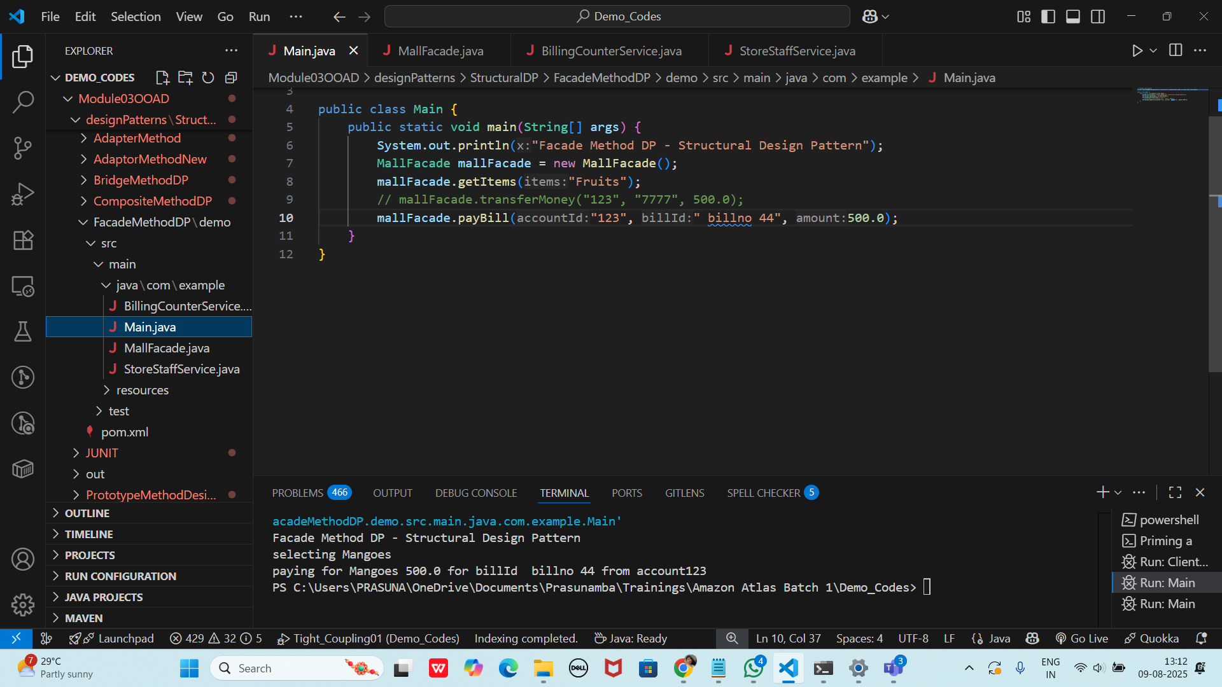

Home Task01:

Bridge Method

I ll give the sample…

Home Task 02:

//🎉

Flyweight

Home Task 03:

Decorator

Link updated excalidraw - 18.09

<https://excalidraw.com/#json=KDKTMT2ib13Az0HOJjGAy,_AQWr8Z-iFGmfbG97kEC4g>

// 7989523779